Student Assessment Submission and Declaration

Module Code
Module Name | Software Foundation
Student Name/s | Mst Rahima Talukdar
BSU ID | 690313
Assessment | Development Project
Submission date | 13/09/2026
Lecturer Name | Moses Bankole

Plagiarism

Plagiarism is a form of cheating. Plagiarism must be avoided at all costs and students who break the rules, however innocently, may be penalised. It is your responsibility to ensure that you understand correct referencing practices. As a university level student, you are expected to use appropriate references throughout and keep carefully detailed notes of all your sources of materials for material you have used in your work, including any material downloaded from the Internet. Please consult the relevant unit lecturer or your course tutor if you need any further advice.

Student declaration
I certify that the assignment submission is entirely my own work. I fully understand the consequences of plagiarism. I understand that making a false declaration is a form of malpractice.
Student signature: | Mst Rahima Talukdar | Date: | 13/09/26

1. Introduction
This project will do the following: Write an Employee Payroll Data Processing Program that will work with the single-employee example (payroll.py) that was provided in the Week 4 materials of the module. In analysing the short, there were three basic requirements: reading in structured data from a file passed in on the command line, performing several distinct but related calculations, and writing these results out to an output file with good commenting and robust error-handling (Van Rossum, Warsaw and Coghlan, 2001). The original example was extended to support multiple employees, to validate all fields before using them, to generate a summary report and to run it via two command-line interfaces.
The full and version-controlled source code has been put up on GitHub at: [INSERT GITHUB REPOSITORY LINK HERE] (see the GitHub upload instructions).

2. Solution Design
The program logic has been designed prior to the writing of the program, using conventions for flowcharts that were discussed in the module (International Organisation for Standardisation, 1985) that sequence, selection and iteration structure would be apparent. The overall flow of the program in the main function is: command line arguments are read, check if the file exists, then read the data, perform calculations, then write the data, then print the summary to the console. The general operation of the main program is: it reads command line arguments, checks if the input file exists, processes the input file with a series of read-calculate-write steps, and displays a summary to the console. There are two decision points to avoid missing arguments or missing files; the program will not crash, but end with a clear message.
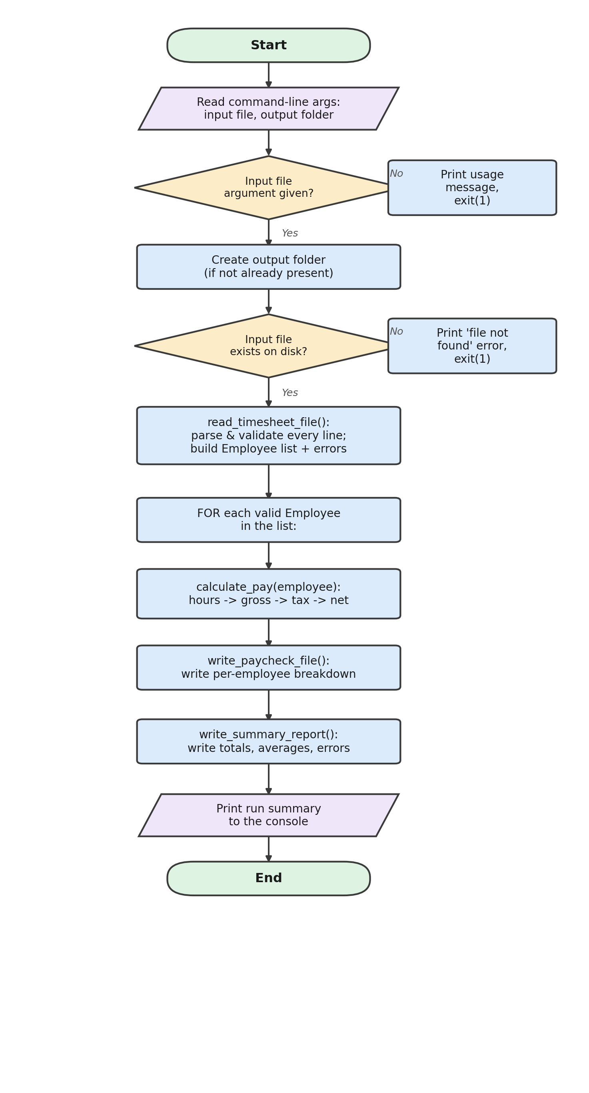
Figure 1: Overall program flow (main())
The most complex part of the design is the function read_timesheet_file(), so this function is explained in detail in Figure 2. Each line is tested three times: first to check if it is a comment or is blank; second to check if it contains the proper number of fields; third to check if all the fields can be converted to a number in the reasonable range (for example, hours could only be in the range 0 to 24, hourly rate should be a positive number). Any line that fails any check is added to an errors list, and the next line of program is executed, but the next line of data is not. The decision to use the “collect and continue” pattern was deliberate, to avoid stopping on the first error; an actual payroll run should not fail due to a typographical error on an employee's timesheet (McConnell, 2004).
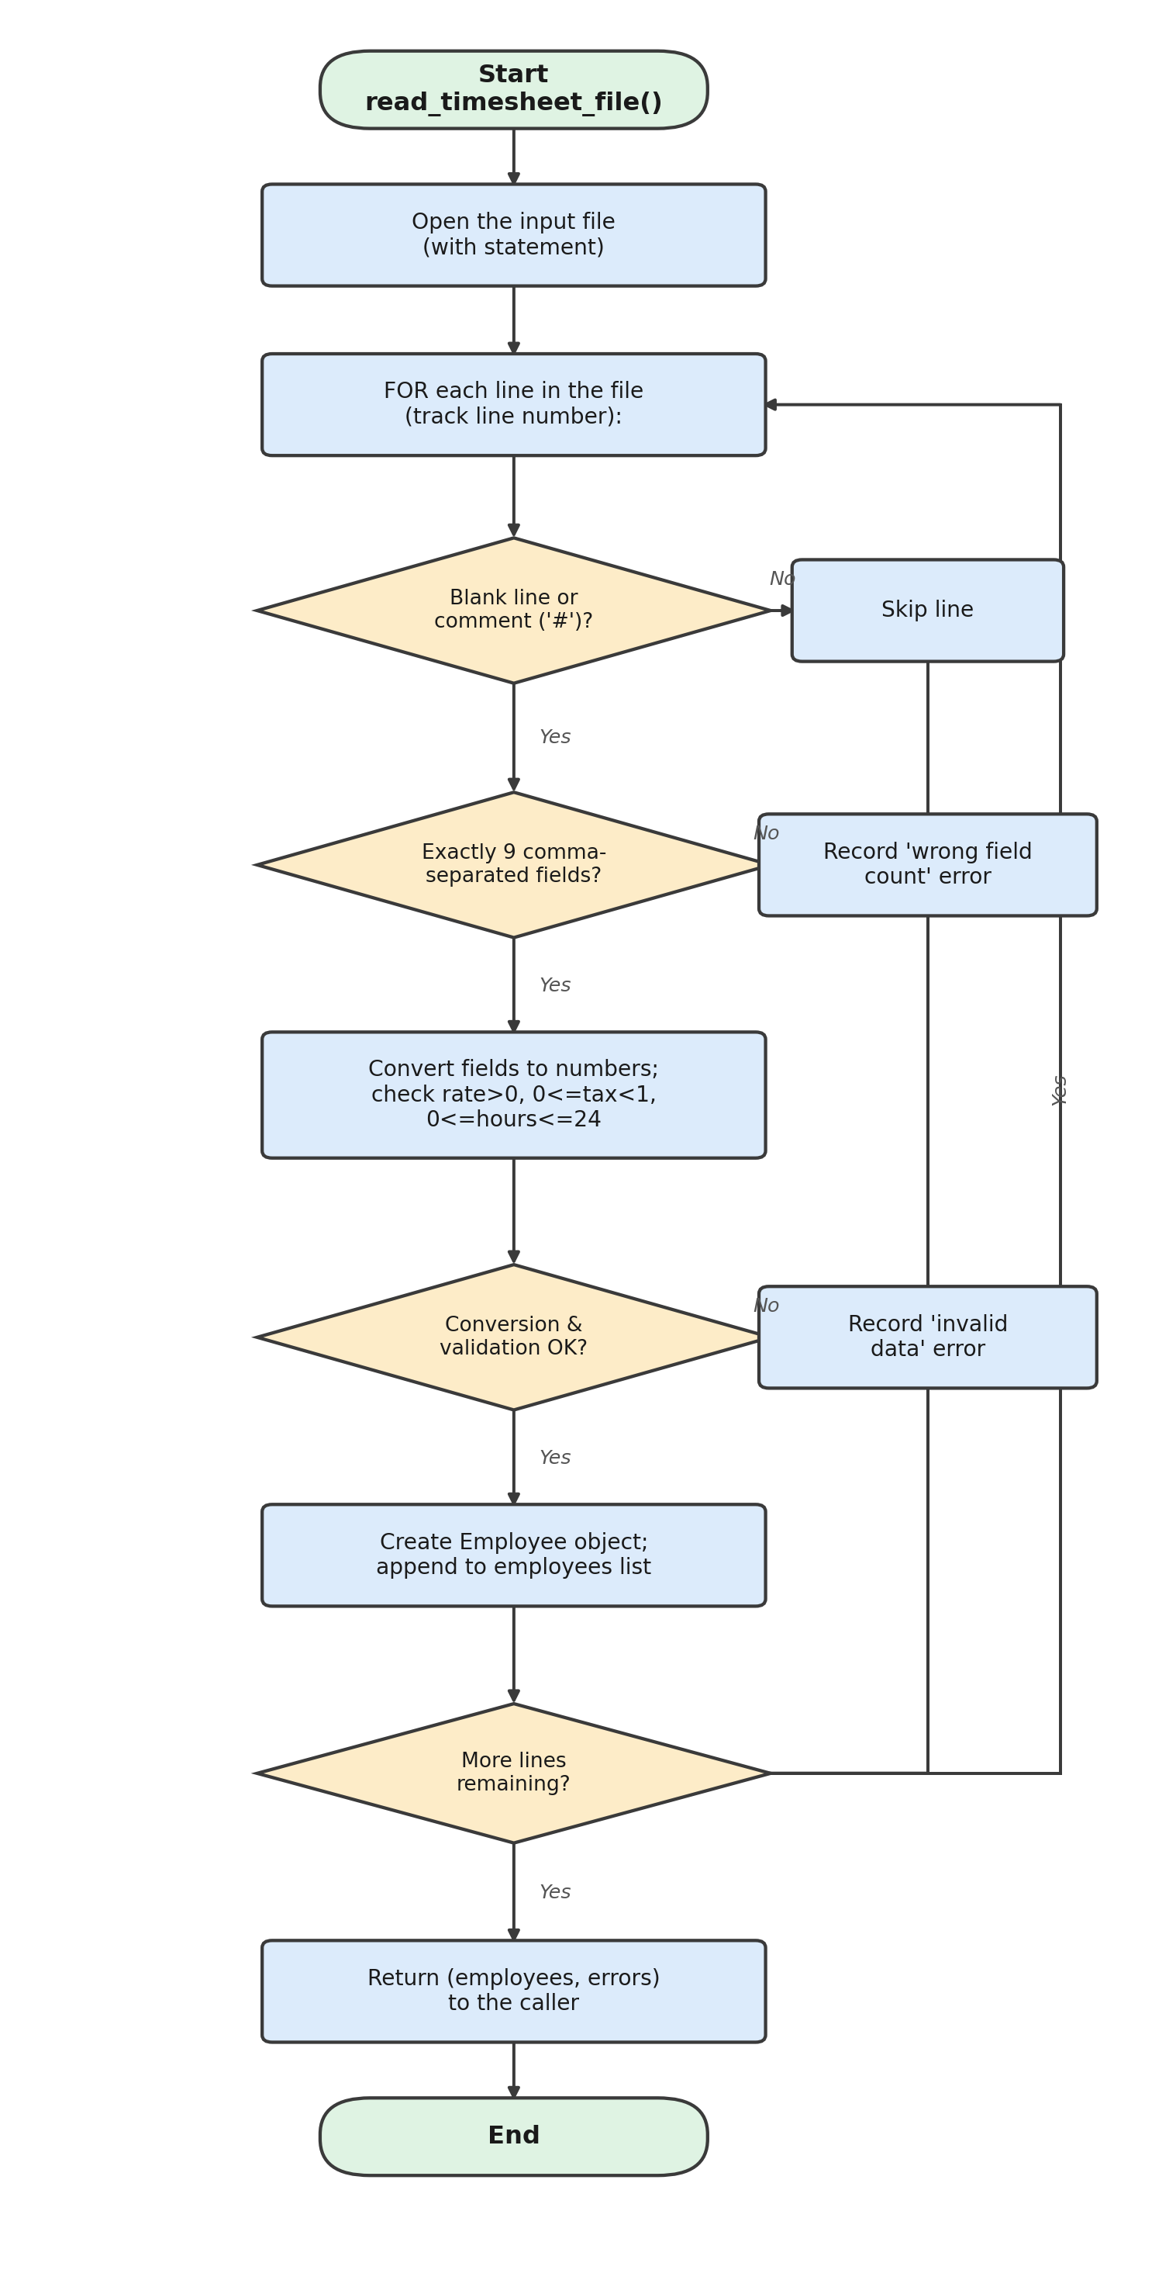
Figure 2: Detail of the read/validate loop inside read_timesheet_file()

Technical breakdown
There are a couple of other design decisions that warrant explanation. Each Employee class gathers all of the input data and all of the output data for each employee; it is not recommended to hand in a few variables from one function to another in the program because it would be hard to keep all of the data for one employee separate from all of the data for another employee, as is required if the program is written readable (Martin, 2009). The calculation logic is contained in one function: calculate_pay(), which does four related calculations: splitting total hours into the two components (regular and overtime hours) based on a user-configurable threshold of 40 hours, computing gross pay including overtime multiplier (1.5X), computing tax due, and computing net pay – more than the brief's minimum requirement of two calculations. The constants (such as overtime threshold, multiplier, etc.) are declared in the upper part of the file for easier finding and modification of business rules (following good coding practice, Van Rossum, Warsaw and Coghlan, 2001).
In addition, there is an optional feature (not required for the minimum specification): a summary report (written by write_summary_report()) that will give the reader a set of figures to be aware of for the entire processing run: total number of employees processed, total number of records rejected, gross company-wide totals and averages, highest and lowest paid employees, and a complete list of any other errors encountered - this will give the reader a "manager-level overview" in addition to the "employee-level detail" that is the meat of the brief.
Lastly, the program is run via two script files (one for Linux/macOS for bash and one for Windows for batch): run_payroll.sh and run_payroll.bat. Both check that the file exists before executing payroll_processor.py, and both are passed the path to the input file as a command-line argument, per the script-file requirements outlined in the brief, on two different platforms. Both test to see if the input file exists prior to calling payroll_processor.py, and both pass the path to the input file as a command-line argument, thus satisfying the brief requirement to execute the script-file on two different platforms. Finally, a second Python script called generate_sample_data.py was written to pre-process the project: to create new timesheet files that can be used for testing, and to generate random timesheet files, as mentioned by the Python Software Foundation (2026).

3. Reflective Evaluation
The most interesting aspect of this project was the design of the read_timesheet_file() error handling strategy. When I started writing it, it was sensitive; if one line was wrong, the whole program would throw an unhandled exception and crash. Making it robust and resilient meant not assuming that it would always be correct; I'm learning how to make it a more robust and resilient program. It was also nice to create the Employee class to show that it is much simpler to have a chain of several calculations all contained within one class rather than have to pass several variables from one calculation to the next.
If I were to go on with this work, I would add an automated test suite (including Python's unittest module) to ensure that the changes in the calculation logic were accurate, as opposed to having to check the output files; and Python's argparse module for more complex command-line parsing, with help text built in. I would also like it packaged as a standalone executable (using, for instance, PyInstaller) and to know more about logging (print statements) to keep track of the program's activities in a production environment. This project also gave me a deeper understanding of some of the skills I already knew about, such as functions, file handling, validation and command-line programs, but also about skills I didn't know yet, such as automated testing and packaging.

4. References
Chacon, S. and Straub, B. (2014) Pro Git. 2nd edn. New York: Apress. Available at: https://git-scm.com/book (Accessed: 28 August 2026).
Downey, A. (2015) Think Python: How to Think Like a Computer Scientist. 2nd edn. Sebastopol, CA: O'Reilly Media.
International Organization for Standardization (1985) ISO 5807:1985 Information processing — Documentation symbols and conventions for data, program and system flowcharts, program network charts and system resources charts. Geneva: ISO.
Martin, R.C. (2009) Clean Code: A Handbook of Agile Software Craftsmanship. Upper Saddle River, NJ: Prentice Hall.
McConnell, S. (2004) Code Complete: A Practical Handbook of Software Construction. 2nd edn. Redmond, WA: Microsoft Press.
Python Software Foundation (2026) The Python Standard Library. Available at: https://docs.python.org/3/library/ (Accessed: 28 August 2026).
Van Rossum, G., Warsaw, B. and Coghlan, N. (2001) PEP 8 – Style Guide for Python Code. Available at: https://peps.python.org/pep-0008/ (Accessed: 28 August 2026).

Appendix: Full Source Code Listing
The following pages contain the complete, unmodified source code submitted to GitHub for this project. This appendix is not included in the word count.
Appendix A: payroll_processor.py (main data processing program)
#!/usr/bin/env python3
"""
payroll_processor.py
---------------------------------------------------------------------------
Employee Payroll Data Processing Program
---------------------------------------------------------------------------
Module : CPUF001 - Software Foundation
Assignment : Development Project (Assessment 1)

Purpose
-------
This program reads employee timesheet data from an input CSV-style text
file (supplied as a command-line argument), performs payroll calculations
(regular pay, overtime pay, tax deduction and net take-home pay) for each
employee, and writes the results to:

1. An output "paycheck" file containing an itemised breakdown for
every employee.
2. A summary "report" file that gives an overview of the whole
payroll run (totals, averages, and any errors encountered).

The program builds on the simple single-employee example provided in the
module materials (week 4: payroll.py, timesheet.txt, paycheck.txt) and
extends it to process multiple employees, multiple data fields per
employee, and to include validation and error handling so that a single
bad record does not stop the whole payroll run.

Usage (from the command line)
------------------------------
python3 payroll_processor.py <input_timesheet_file> [output_folder]

Example:
python3 payroll_processor.py data/timesheet.txt output

Input file format
------------------
Each line in the input file represents ONE employee, with the following
comma-separated fields (9 values per line - well above the brief's
minimum requirement of 3 data values read from the file):

EmployeeID,Name,HourlyRate,TaxRate,MonHours,TueHours,WedHours,
ThuHours,FriHours

Example line:
E001,Amelia Turner,14.50,0.20,8,7.5,8,8,6

Lines starting with '#' are treated as comments and skipped.
---------------------------------------------------------------------------
"""

import sys
import os
from datetime import datetime

# ---------------------------------------------------------------------------
# Configuration constants
# ---------------------------------------------------------------------------
# Grouping these "magic numbers" as named constants (rather than scattering
# literal values through the code) makes the rules of the business easy to
# find and change in one place - an example of writing maintainable code.
OVERTIME_THRESHOLD_HOURS = 40.0 # hours per week before overtime applies
OVERTIME_MULTIPLIER = 1.5 # overtime is paid at 1.5x the normal rate
EXPECTED_FIELD_COUNT = 9 # EmployeeID, Name, Rate, Tax, 5 day hours

# ---------------------------------------------------------------------------
# Data structure
# ---------------------------------------------------------------------------
class Employee:
"""
Represents a single employee's timesheet record and the payroll
results calculated for them.

Using a class here (rather than passing several loose variables or a
plain tuple around) keeps each employee's data and results bundled
together, which makes the rest of the program easier to read and
reduces the chance of mixing up one employee's figures with another's.
"""

def __init__(self, employee_id, name, hourly_rate, tax_rate, daily_hours):
self.employee_id = employee_id
self.name = name
self.hourly_rate = hourly_rate
self.tax_rate = tax_rate
self.daily_hours = daily_hours # list of 5 floats
self.total_hours = 0.0
self.regular_hours = 0.0
self.overtime_hours = 0.0
self.gross_pay = 0.0
self.tax_amount = 0.0
self.net_pay = 0.0

# ---------------------------------------------------------------------------
# Function: read_timesheet_file
# ---------------------------------------------------------------------------
def read_timesheet_file(file_name):
"""
Read and parse the timesheet input file.

Each valid line is converted into an Employee object. Lines that are
blank or start with '#' are skipped. Lines that are malformed
(wrong number of fields, or fields that cannot be converted to the
expected numeric type) are NOT allowed to crash the whole program;
instead they are recorded as errors and processing continues with
the remaining lines. This satisfies the "error checking and
handling, especially with files" requirement.

Parameters
----------
file_name : str
Path to the input timesheet file.

Returns
-------
tuple (list[Employee], list[str])
A list of successfully parsed Employee objects, and a list of
human-readable error messages for any lines that failed to parse.

Raises
------
FileNotFoundError
Propagated to the caller if the file itself cannot be opened, so
that the top-level program can report a clear message and exit
cleanly rather than printing a raw Python traceback.
"""
employees = []
errors = []

with open(file_name, "r") as file: # 'with' guarantees the file is closed
for line_number, raw_line in enumerate(file.readlines(), start=1):
line = raw_line.strip()

# Skip blank lines and comment lines
if not line or line.startswith("#"):
continue

fields = [f.strip() for f in line.split(",")]

if len(fields) != EXPECTED_FIELD_COUNT:
errors.append(
f"Line {line_number}: expected {EXPECTED_FIELD_COUNT} "
f"fields but found {len(fields)} -> '{line}'"
)
continue

try:
employee_id = fields[0]
name = fields[1]
hourly_rate = float(fields[2])
tax_rate = float(fields[3])
daily_hours = [float(h) for h in fields[4:9]]

# Basic sanity / validation checks (defensive programming)
if hourly_rate <= 0:
raise ValueError("hourly rate must be greater than zero")
if not (0 <= tax_rate < 1):
raise ValueError("tax rate must be between 0 and 1")
if any(h < 0 or h > 24 for h in daily_hours):
raise ValueError("daily hours must be between 0 and 24")

employees.append(
Employee(employee_id, name, hourly_rate, tax_rate, daily_hours)
)

except ValueError as err:
errors.append(f"Line {line_number}: invalid data ({err}) -> '{line}'")

return employees, errors

# ---------------------------------------------------------------------------
# Function: calculate_pay
# ---------------------------------------------------------------------------
def calculate_pay(employee):
"""
Perform the payroll calculations for one employee and store the
results directly on the Employee object.

Calculations performed (this satisfies the "at least 2 calculations"
requirement - four related calculations are performed here):
1. Total hours worked, split into regular hours and overtime hours
2. Gross pay (regular pay + overtime pay at 1.5x rate)
3. Tax deducted (gross pay * employee tax rate)
4. Net (take-home) pay (gross pay - tax)

Parameters
----------
employee : Employee
The employee record to calculate pay for. Modified in place.
"""
employee.total_hours = sum(employee.daily_hours)

if employee.total_hours > OVERTIME_THRESHOLD_HOURS:
employee.regular_hours = OVERTIME_THRESHOLD_HOURS
employee.overtime_hours = employee.total_hours - OVERTIME_THRESHOLD_HOURS
else:
employee.regular_hours = employee.total_hours
employee.overtime_hours = 0.0

regular_pay = employee.regular_hours * employee.hourly_rate
overtime_pay = employee.overtime_hours * employee.hourly_rate * OVERTIME_MULTIPLIER

employee.gross_pay = regular_pay + overtime_pay
employee.tax_amount = employee.gross_pay * employee.tax_rate
employee.net_pay = employee.gross_pay - employee.tax_amount

# ---------------------------------------------------------------------------
# Function: write_paycheck_file
# ---------------------------------------------------------------------------
def write_paycheck_file(output_file_name, employees):
"""
Write a formatted, itemised paycheck breakdown for every employee to
the given output file.

Parameters
----------
output_file_name : str
Path of the paycheck file to create/overwrite.
employees : list[Employee]
Employees to include in the file (in the order supplied).
"""
with open(output_file_name, "w") as file:
file.write("=" * 60 + "\n")
file.write("EMPLOYEE PAYCHECK BREAKDOWN\n")
file.write(f"Generated: {datetime.now().strftime('%Y-%m-%d %H:%M:%S')}\n")
file.write("=" * 60 + "\n\n")

for emp in employees:
file.write(f"Employee ID : {emp.employee_id}\n")
file.write(f"Name : {emp.name}\n")
file.write(f"Hourly Rate : £{emp.hourly_rate:.2f}\n")
file.write(f"Total Hours : {emp.total_hours:.2f}\n")
file.write(f"Regular Hours : {emp.regular_hours:.2f}\n")
file.write(f"Overtime Hours: {emp.overtime_hours:.2f}\n")
file.write(f"Gross Pay : £{emp.gross_pay:.2f}\n")
file.write(f"Tax ({emp.tax_rate*100:.0f}%) : £{emp.tax_amount:.2f}\n")
file.write(f"Net Pay : £{emp.net_pay:.2f}\n")
file.write("-" * 60 + "\n")

# ---------------------------------------------------------------------------
# Function: write_summary_report
# ---------------------------------------------------------------------------
def write_summary_report(report_file_name, employees, errors, input_file_name):
"""
Write a summary report of the whole payroll processing run.

This is an additional feature beyond the brief's minimum requirements
("Output of report file that summarises processing activity") and
gives a manager-level overview rather than per-employee detail.

Parameters
----------
report_file_name : str
Path of the report file to create/overwrite.
employees : list[Employee]
Successfully processed employees.
errors : list[str]
Any error messages generated while reading/validating the input.
input_file_name : str
The original input file name, included for traceability.
"""
with open(report_file_name, "w") as file:
file.write("=" * 60 + "\n")
file.write("PAYROLL PROCESSING SUMMARY REPORT\n")
file.write(f"Generated : {datetime.now().strftime('%Y-%m-%d %H:%M:%S')}\n")
file.write(f"Source : {input_file_name}\n")
file.write("=" * 60 + "\n\n")

file.write(f"Employees successfully processed : {len(employees)}\n")
file.write(f"Records skipped due to errors : {len(errors)}\n\n")

if employees:
total_gross = sum(e.gross_pay for e in employees)
total_tax = sum(e.tax_amount for e in employees)
total_net = sum(e.net_pay for e in employees)
average_net = total_net / len(employees)
highest_paid = max(employees, key=lambda e: e.net_pay)
lowest_paid = min(employees, key=lambda e: e.net_pay)

file.write(f"Total gross pay (all employees) : £{total_gross:.2f}\n")
file.write(f"Total tax deducted : £{total_tax:.2f}\n")
file.write(f"Total net pay (all employees) : £{total_net:.2f}\n")
file.write(f"Average net pay per employee : £{average_net:.2f}\n\n")
file.write(f"Highest paid employee : {highest_paid.name} (£{highest_paid.net_pay:.2f})\n")
file.write(f"Lowest paid employee : {lowest_paid.name} (£{lowest_paid.net_pay:.2f})\n")
else:
file.write("No employee records were successfully processed.\n")

if errors:
file.write("\n" + "-" * 60 + "\n")
file.write("ERRORS ENCOUNTERED\n")
file.write("-" * 60 + "\n")
for error in errors:
file.write(f" - {error}\n")

# ---------------------------------------------------------------------------
# Function: main
# ---------------------------------------------------------------------------
def main():
"""
Program entry point. Reads command-line arguments, orchestrates the
read -> calculate -> write pipeline, and handles top-level errors so
the user always sees a clear message instead of a raw traceback.
"""
# --- Command line argument handling -----------------------------------
if len(sys.argv) < 2:
print("Usage: python3 payroll_processor.py <input_timesheet_file> [output_folder]")
sys.exit(1)

input_file_name = sys.argv[1]
output_folder = sys.argv[2] if len(sys.argv) >= 3 else "output"

# Make sure the output folder exists before we try to write into it
os.makedirs(output_folder, exist_ok=True)

paycheck_file = os.path.join(output_folder, "paycheck.txt")
report_file = os.path.join(output_folder, "report.txt")

# --- Read and validate input --------------------------------------
try:
employees, errors = read_timesheet_file(input_file_name)
except FileNotFoundError:
print(f"ERROR: Input file '{input_file_name}' was not found. "
f"Please check the file path and try again.")
sys.exit(1)
except OSError as err:
print(f"ERROR: Could not read '{input_file_name}': {err}")
sys.exit(1)

# --- Calculate pay for every valid employee -----------------------
for employee in employees:
calculate_pay(employee)

# --- Write output files --------------------------------------------
write_paycheck_file(paycheck_file, employees)
write_summary_report(report_file, employees, errors, input_file_name)

# --- Console feedback for the user ----------------------------------
print(f"Processed {len(employees)} employee record(s) from '{input_file_name}'.")
if errors:
print(f"{len(errors)} record(s) were skipped due to errors "
f"(see {report_file} for details).")
print(f"Paycheck details written to : {paycheck_file}")
print(f"Summary report written to : {report_file}")

# Standard Python entry-point guard: code inside this block only runs
# when the file is executed directly (e.g. `python3 payroll_processor.py`),
# not when it is imported as a module by another script.
if __name__ == "__main__":
main()

Appendix B: generate_sample_data.py (pre-processing / test-data script)
#!/usr/bin/env python3
"""
generate_sample_data.py
---------------------------------------------------------------------------
Pre-processing / test-data generation script.

This is a SECOND, separate script (in addition to the main
payroll_processor.py program) that creates a randomised timesheet input
file. It is useful for generating fresh test data to demonstrate that the
main program works correctly for different inputs, and satisfies the
optional brief feature: "Use of multiple scripts that pre- or post-process
the data files".

Usage:
python3 generate_sample_data.py [number_of_employees] [output_file]

Example:
python3 generate_sample_data.py 10 data/timesheet_random.txt
---------------------------------------------------------------------------
"""

import sys
import random

# A small pool of sample names used to build believable-looking test data
FIRST_NAMES = ["Amelia", "Noah", "Rahima", "Liam", "Sophia", "Omar",
"Grace", "Ethan", "Priya", "Jack"]
LAST_NAMES = ["Turner", "Ahmed", "Begum", "Smith", "Chowdhury",
"Walker", "Rahman", "Hughes", "Patel", "Brooks"]

def generate_employee_line(employee_number):
"""
Build one comma-separated timesheet line for a single fictitious
employee, with a random hourly rate, tax rate and five days of
random working hours (occasionally including overtime so the main
program's overtime logic is exercised by the sample data).

Parameters
----------
employee_number : int
Used to build a simple, unique employee ID (e.g. E001, E002...).

Returns
-------
str
A single formatted timesheet line, without a trailing newline.
"""
employee_id = f"E{employee_number:03d}"
name = f"{random.choice(FIRST_NAMES)} {random.choice(LAST_NAMES)}"
hourly_rate = round(random.uniform(11.50, 22.00), 2)
tax_rate = round(random.uniform(0.15, 0.25), 2)
# Most days are a normal 6-9 hour shift; occasionally push hours up
# so that some employees trigger the overtime calculation.
daily_hours = [round(random.uniform(6.0, 9.5), 1) for _ in range(5)]

fields = [employee_id, name, f"{hourly_rate}", f"{tax_rate}"] + \
[f"{h}" for h in daily_hours]
return ",".join(fields)

def main():
"""Entry point: parse arguments and write the generated file."""
employee_count = int(sys.argv[1]) if len(sys.argv) >= 2 else 5
output_file = sys.argv[2] if len(sys.argv) >= 3 else "data/timesheet_random.txt"

with open(output_file, "w") as file:
file.write("# Auto-generated sample timesheet data\n")
file.write("# EmployeeID,Name,HourlyRate,TaxRate,Mon,Tue,Wed,Thu,Fri\n")
for i in range(1, employee_count + 1):
file.write(generate_employee_line(i) + "\n")

print(f"Generated {employee_count} sample employee record(s) -> {output_file}")

if __name__ == "__main__":
main()

Appendix C: run_payroll.sh (Linux / macOS CLI script)
#!/bin/bash
# ---------------------------------------------------------------------------
# run_payroll.sh
# ---------------------------------------------------------------------------
# Script file that executes the Data Processing program from a
# Command Line Interface (CLI) on Linux / macOS (bash).
#
# It demonstrates the "Script file" deliverable required by the brief:
# - It runs from an accepted CLI (bash)
# - It executes the Data Processing program (payroll_processor.py),
# passing an available data file in as a command-line argument
# - It includes comments that explain each step
#
# Usage:
# ./run_payroll.sh (uses the default sample file)
# ./run_payroll.sh data/myfile.txt (uses a specific input file)
# ---------------------------------------------------------------------------

# Stop the script immediately if any command fails (basic error handling)
set -e

# If the user supplies an input file as the first argument, use it.
# Otherwise, fall back to the sample timesheet included with the project.
INPUT_FILE="${1:-data/timesheet.txt}"
OUTPUT_FOLDER="output"

echo "============================================================"
echo " Running Payroll Data Processing Program"
echo " Input file : $INPUT_FILE"
echo "============================================================"

# Check the input file exists before trying to run the program, so we
# can give the user a clear message instead of a Python traceback.
if [ ! -f "$INPUT_FILE" ]; then
echo "ERROR: Input file '$INPUT_FILE' was not found."
exit 1
fi

# Execute the main Python data processing program, passing the input
# file and output folder in as command-line arguments.
python3 payroll_processor.py "$INPUT_FILE" "$OUTPUT_FOLDER"

echo "============================================================"
echo " Done. See the '$OUTPUT_FOLDER' folder for paycheck.txt and report.txt"
echo "============================================================"

Appendix D: run_payroll.bat (Windows CLI script)
@echo off
REM ---------------------------------------------------------------------
REM run_payroll.bat
REM ---------------------------------------------------------------------
REM Script file that executes the Data Processing program from a
REM Command Line Interface (CLI) on Windows.
REM
REM This is provided alongside run_payroll.sh (bash) so the project can
REM be run from an accepted CLI on more than one platform - an example
REM of the optional "Use of multiple scripting languages for use on
REM different platforms" feature from the brief.
REM
REM Usage:
REM run_payroll.bat (uses the default sample file)
REM run_payroll.bat data\myfile.txt (uses a specific input file)
REM ---------------------------------------------------------------------

REM %1 is the first command-line argument passed to this script.
REM If it was not supplied, fall back to the sample timesheet file.
SET INPUT_FILE=%1
IF "%INPUT_FILE%"=="" SET INPUT_FILE=data\timesheet.txt
SET OUTPUT_FOLDER=output

echo ============================================================
echo Running Payroll Data Processing Program
echo Input file : %INPUT_FILE%
echo ============================================================

REM Check the input file exists before running the program
IF NOT EXIST "%INPUT_FILE%" (
echo ERROR: Input file "%INPUT_FILE%" was not found.
exit /b 1
)

REM Execute the main Python data processing program, passing the input
REM file and output folder in as command-line arguments.
python payroll_processor.py "%INPUT_FILE%" "%OUTPUT_FOLDER%"

echo ============================================================
echo Done. See the "%OUTPUT_FOLDER%" folder for paycheck.txt and report.txt
echo ============================================================

